**Shivam Navnath Giri  
PGDAI – Silchar**

**Lab Asssesment Test AI – Trends**

**Date – 16/10/2024**

**Q. USING ML-OPS, BUILD a python script THAT UNDERGOES THE**

**PROCESSES USING GIT, DOCKER AND JENKINS**

**PERFORM USING THE SCREEN SHOT OF YOUR ACCOUNT LOGIN**

Create a local git repository

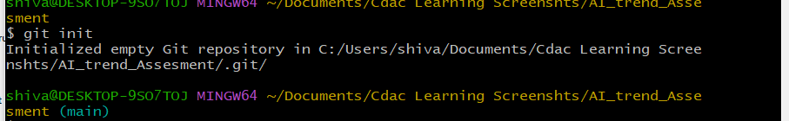

Commit the initial code

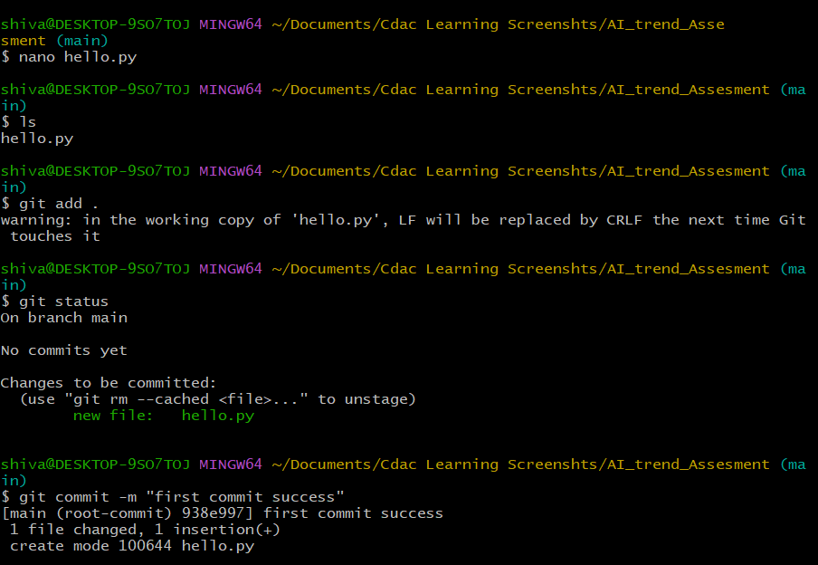

Update the code on the remote server. Also perform some changes on remote n reflect the

same on local.

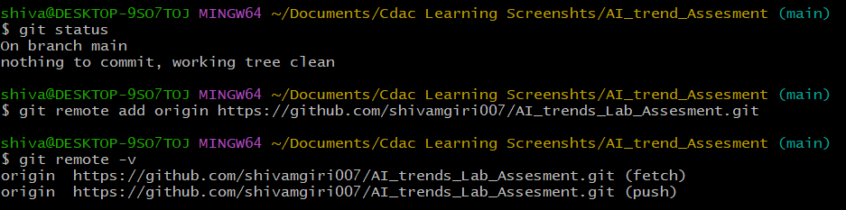

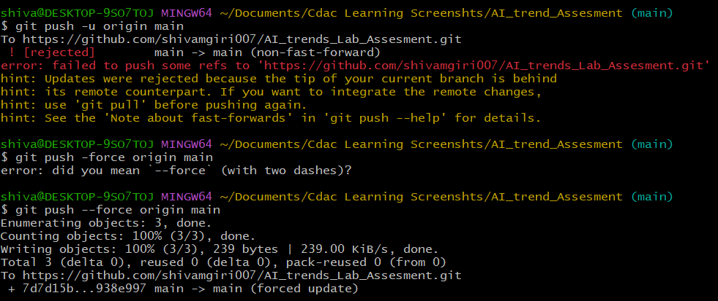

perform some changes on remote n reflect the same on local.

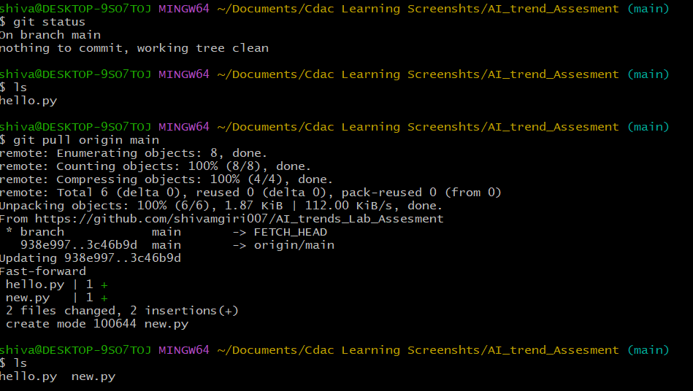

Use git commands to

to create branches in git

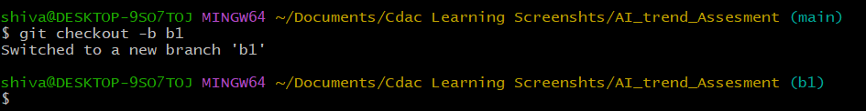

diff between branches

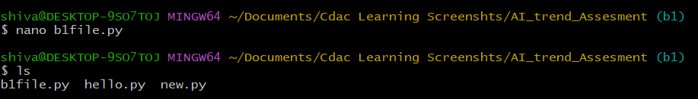

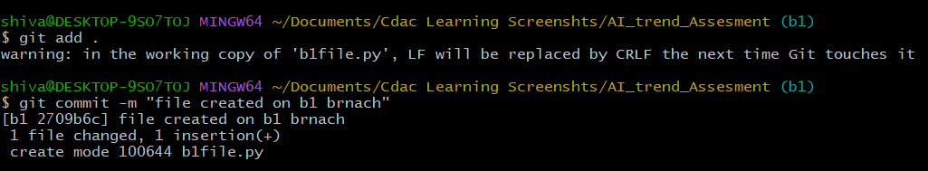

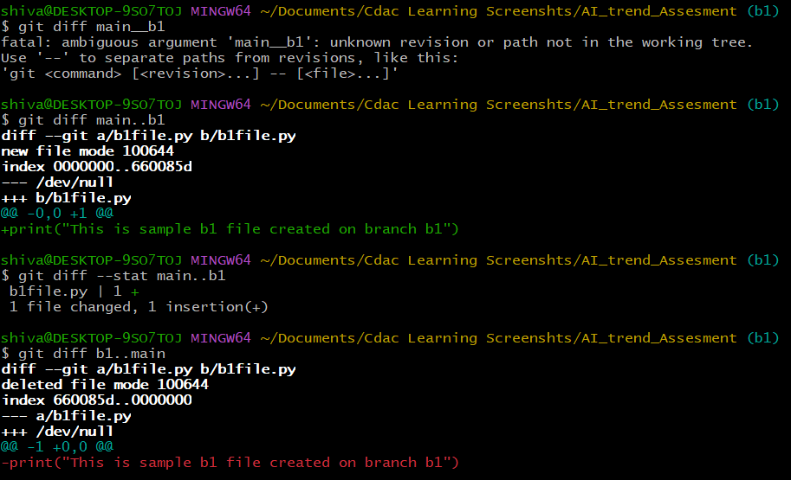

logs of the commit

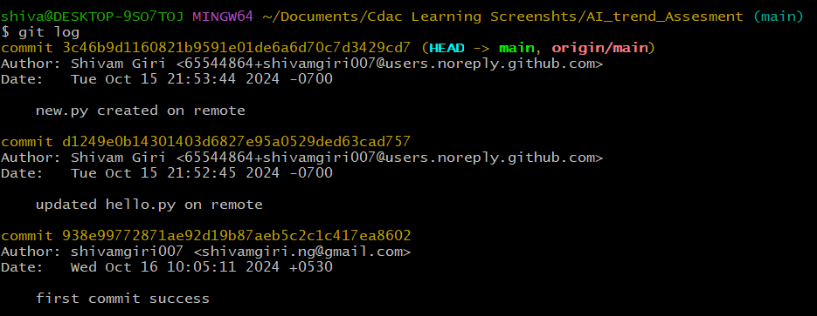

Revert of changes

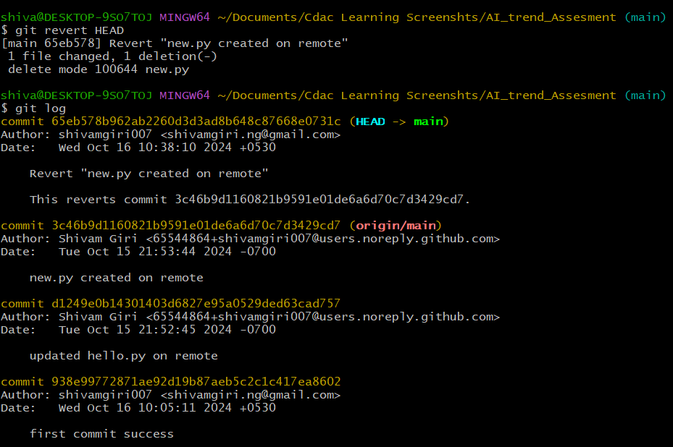

Deploy your application script in the Docker. And register ur image



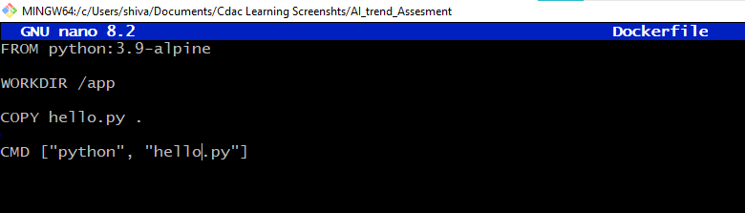 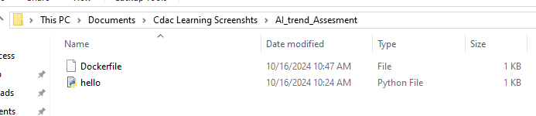

Deployed image

Build/ dockerfile

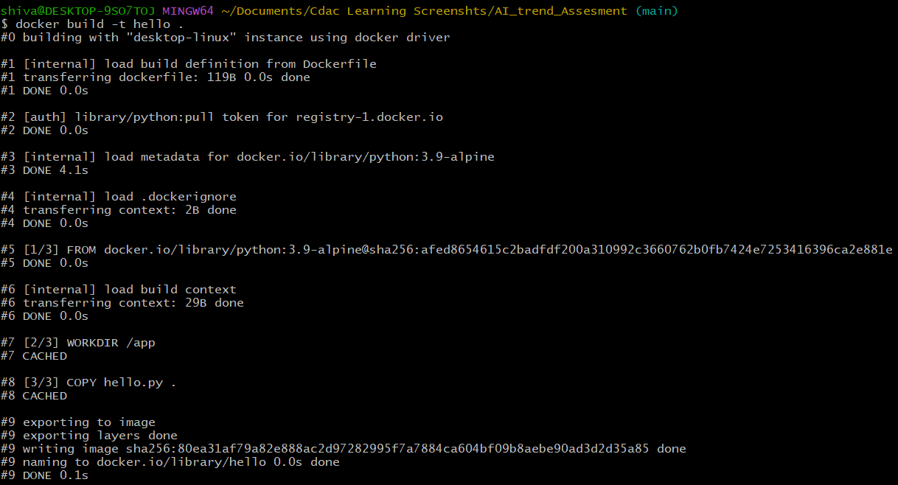 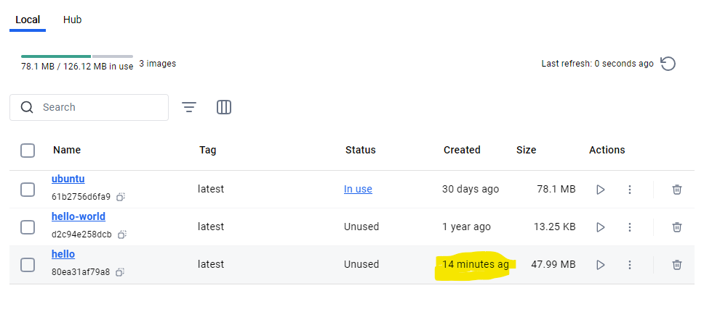 

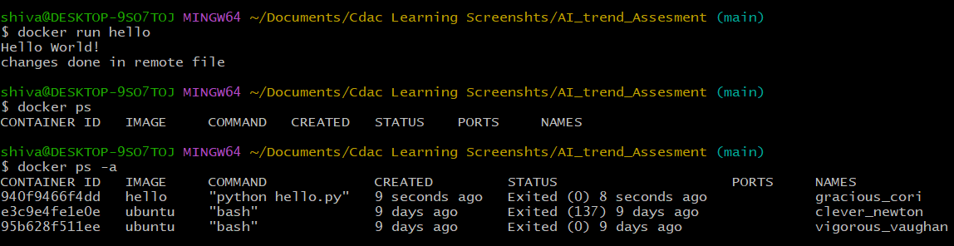

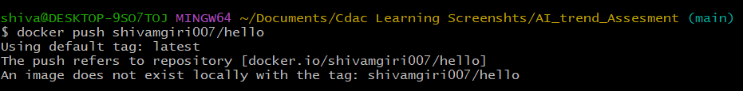

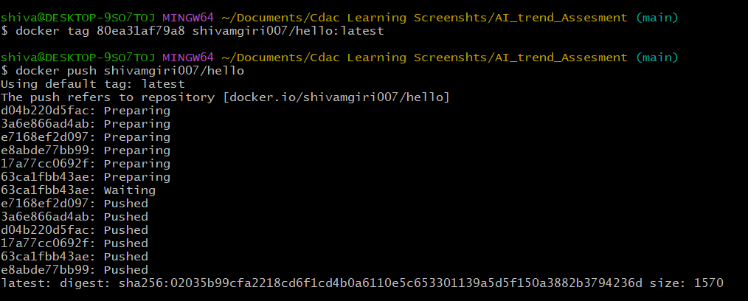

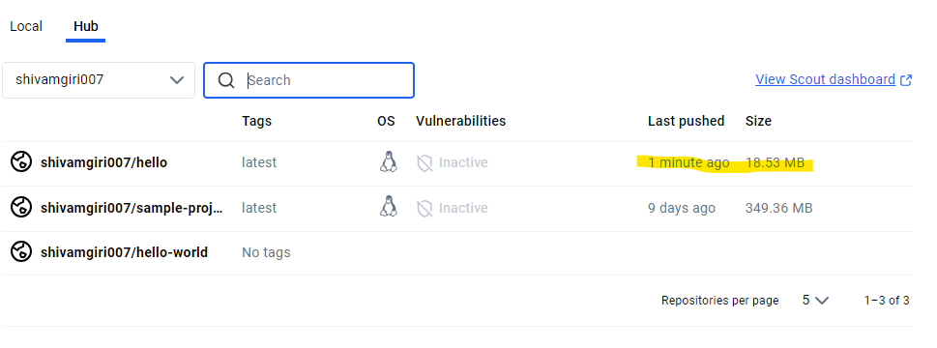

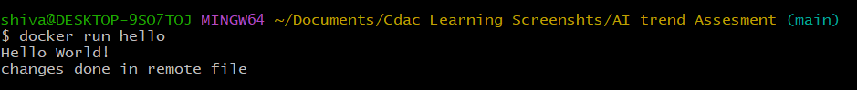

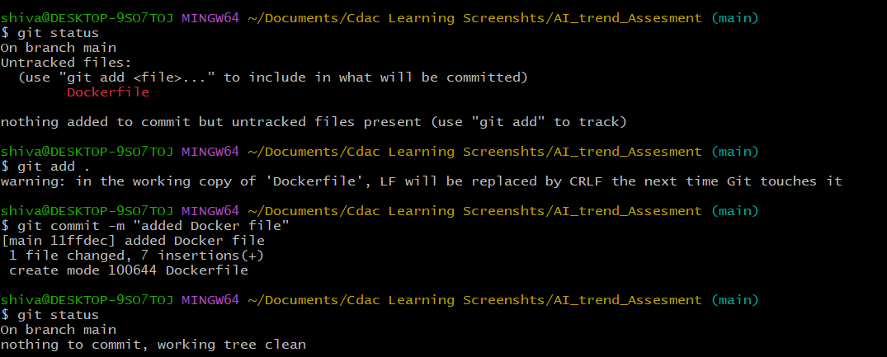

Automate the build using Build Triggers w.r.t SCM (Git)

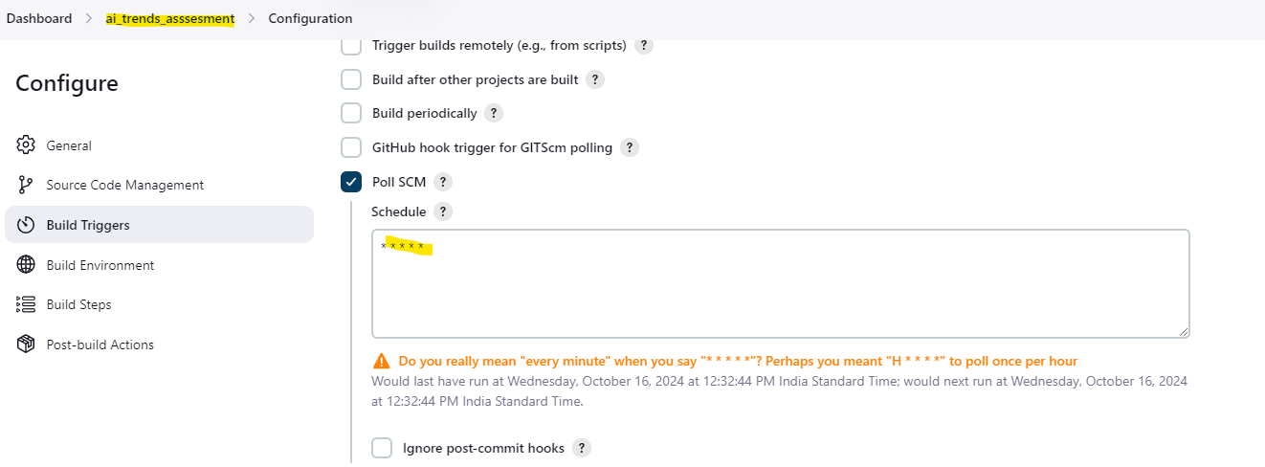

Create a Repository on Git and connect the created branch b1/master with the Jenkins and

ensure the automation on the build initiated periodic triggers via any changes pushed to the

github.[console o/p, configure, build ]

